Shared decision making – IT meets patient-centered care
Imagine this: Mrs. Smith, a patient of yours, suffers from degenerative joint disease in her back. She comes to your office to see if it makes sense to have surgery. Because of a computerized decision aid, Mrs. Smith has already been educated about the various options and the fact that there are trade-offs between those options. She has viewed evidence about risks and benefits, and is clear about what her preferences are, and what information she still needs from you. She also has watched videoclips from patients who describe what their experience has been with the various therapeutic options. Now you, as her physician, don’t have to spend your limited time with her repeating information that is readily available elsewhere. You can spend your time exploring with her what the best decision is for her, given her preferences, her values, and her unique situation.
That is the aim of shared decision making.

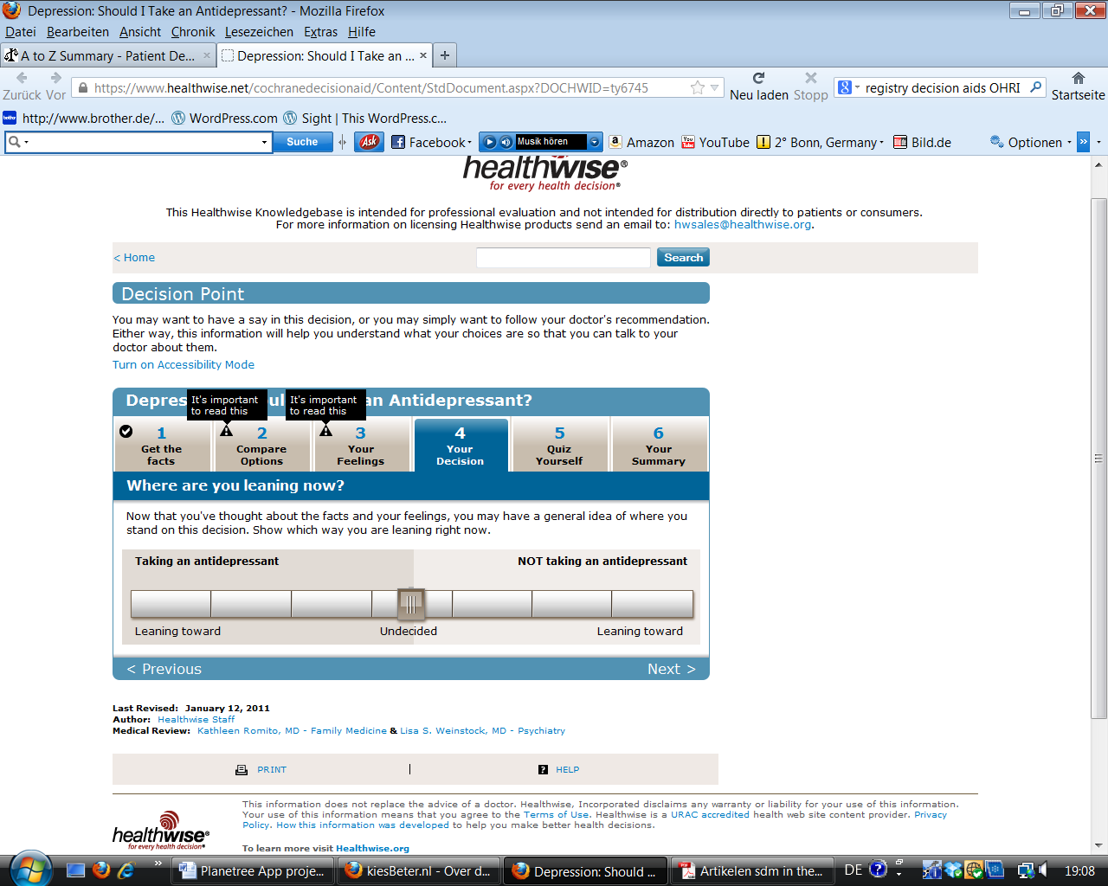

What is shared decision making?
In shared decision making, clinicians and patients communicate together using the best available evidence to arrive at informed preferences in making a decision. The principle is nothing new, but the model has the promise for better decisions through actively involving patients in identifying their preferences and values, and in the use of decision aids. Decision aids can be paper-based or electronic, and are effective at facilitating shared decision making. High quality decision aids do more than just present information on options: They stimulate patients to think about their preferences and to clarify their values; they offer information from patients who have undergone the procedure themselves, and they have been evaluated in prospective trials. Decision aids can be given to patients before or after the consultation to prepare decisions and clarify options. Many patients find it easier to clarify what is important to them and share private information with a computer than in the consultation setting.

Shared Decision Making is actively being trialed and evaluated in the Netherlands, and many online decision aids in English and Dutch are available. However, decision aids are not widely implemented.

Why is shared decision making important?
Dutch health care law has enshrined the patient’s right to be involved in medical decision making. Patient involvement in decision making is of particular importance for preference-sensitive conditions. Preference-sensitive conditions are those where there are different legitimate treatment options with different trade-offs of risks and benefits.- One example of a preference-sensitive condition is in the treatment of prostate cancer, where surgical treatment options might improve life expectancy, but at the cost of significant side effects.

In spite of the aim of full patient involvement, many medical decisions fail to meet minimum standards for informed decision making. For many invasive procedures, variations in care seem not aligned with patients’ preferences, but more with physician’s local practice habits or payment incentives.³ Where patient preferences are taken into account, patients often choose differently than physicians, and choose less invasive options. When patients do choose invasive options, they are better informed and more motivated to comply with follow-up care and rehab. For patients with mental illness, patients offer more information about their condition and preferences when working with a decision aid; and compliance and outcomes are better when patient preferences about side effect profiles are taken into account.

The main promise for health care institutions in general, and Planetree institutions in particular, lies in this triple effect of shared decision making: better decisions for patients, more efficient use of time for physicians, more efficient use of resources for institutions. Decision aids offer an opportunity to enhance patient information of their condition and various treatment options, and to clarify their preferences in preparation for decision making. Moreover, well designed decision aids can help patients organize their thoughts and identify and voice concerns they might not have otherwise been able to share. Physicians have a more efficient consultation because they have to spend less time eliciting or sharing generic information. The time saved can be spent more efficiently addressing patients’ specific concerns, and making sure decisions taken match the patients’ preferences as far as possible. Well-matched decisions in turn lead to more appropriate use of expensive and invasive procedures and better patient adherence

Shared Decision Making is actively being trialed and evaluated in the Netherlands, and many online decision aids in English and Dutch are available.

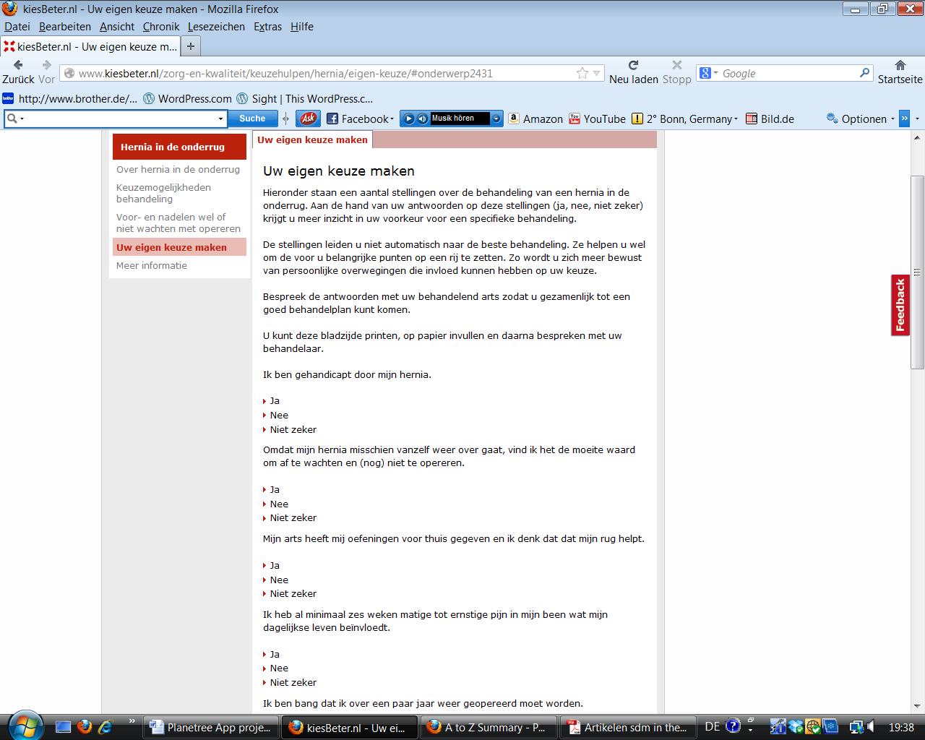
There are many examples of good decision aids already available to patients: Some offer a quiz at the end of the decision aid to ensure understanding. Some help the patients visualize their preferences. Some offer patient stories about their experience with a particular procedure.
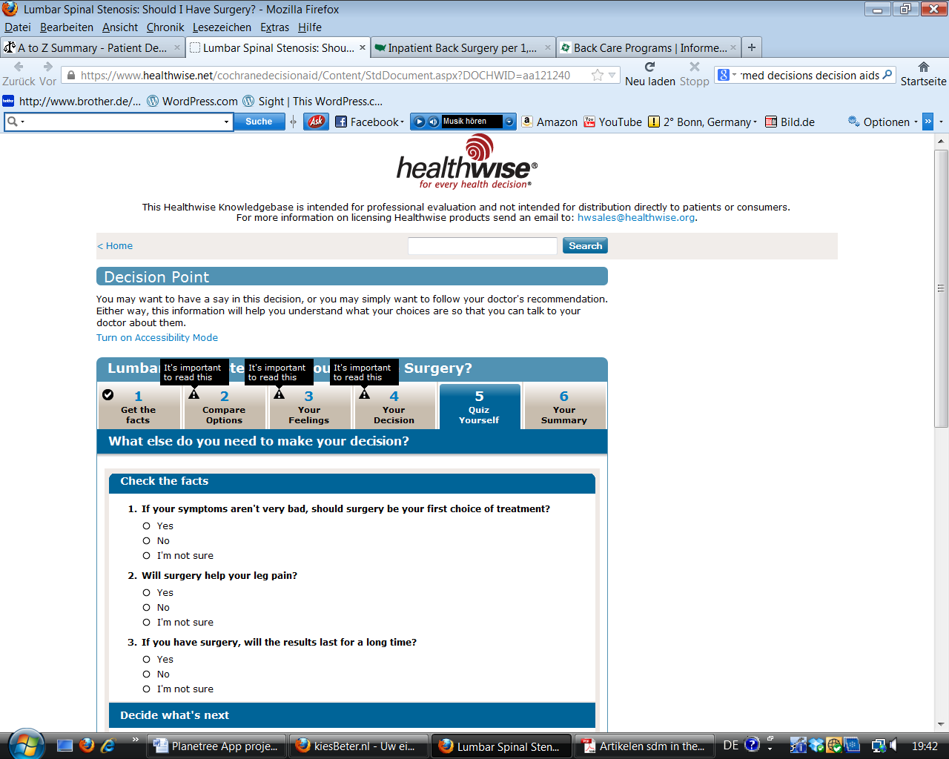
- Decision Aid helps patient visualize their preferences and decision (see below from a decision aid on depression)

- Decision Aid leads to a more open and honest conversation than would happen without it (see below from howsyourhealth.org/frail)
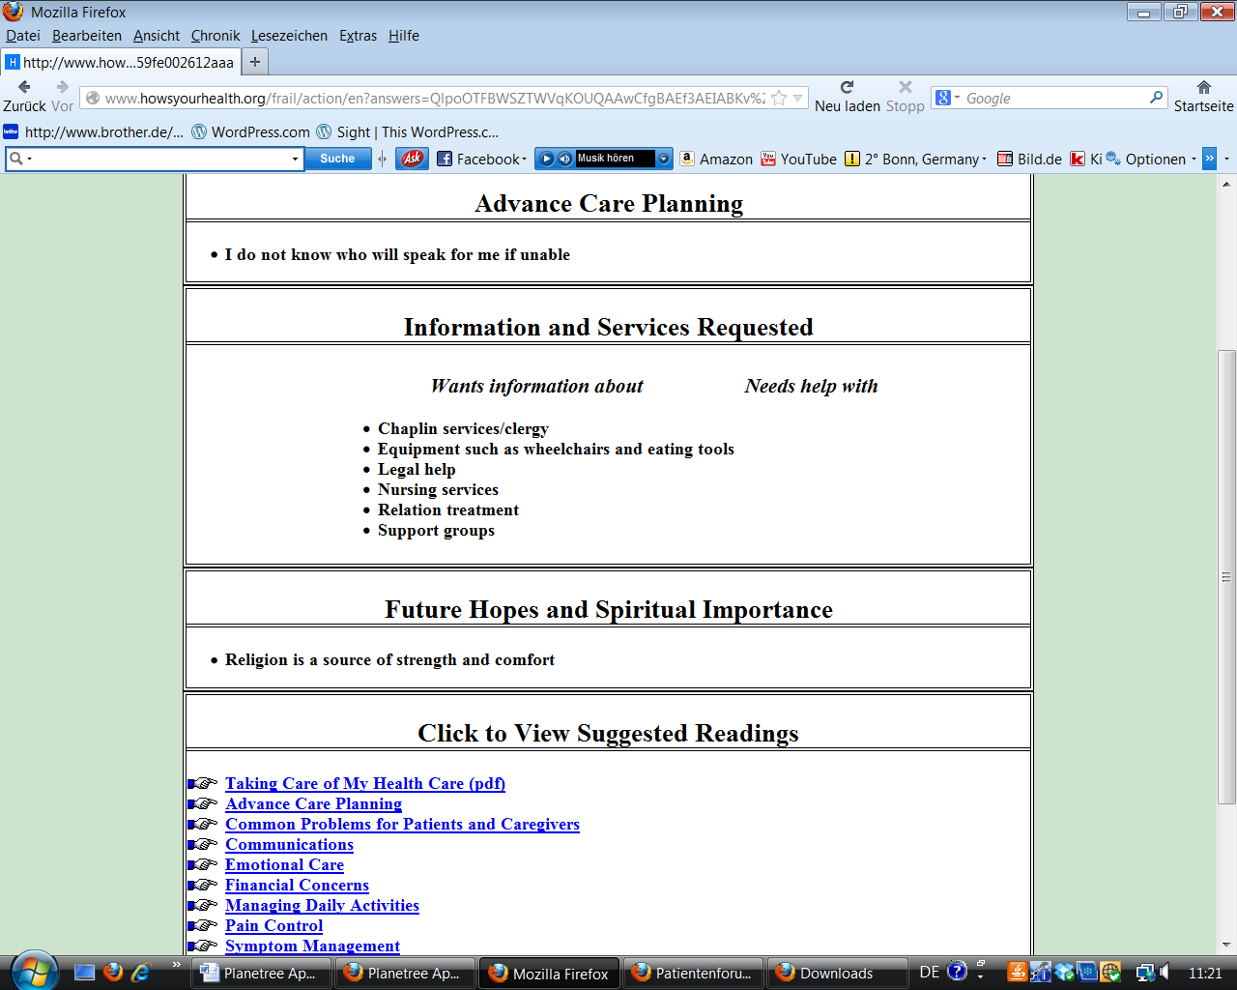

A Planetree App for shared decision making?
The Planetree Knowledge Center is also interested in co-creating with interested organizations a useful decision aid app that can be integrated into the clinical encounter. If you are interested in this project, please email Dorothea (dwild@planetree.org) __________________________________________________________________________________
Dorothea Wild 6/28/2013.

Stacey D, Bennett CL, Barry MJ, et al: Decision Aids for people facing health treatment or screening decisions. Cochrane Database Syst. Rev 2011;10;CD001431.
V.d. Weijden T et al: Shared decision making in the Netherlands, is the time ripe for nationwide, structural implementation? Z Arztl Fortbild Qualitatssich. 2011 downloaded at www.zelfmanagement.com/.../artikelen-sdm-in-the-netherlands-2011..
http://decisionaid.ohri.ca/AZinvent.php
http://www.kiesbeter.nl/zorg-en-kwaliteit/keuzehulpen/default.aspx
V.d. Weijden T, v Veenendaal H, Timmermans D: Shared Decision-Making in the Netherlands- current state and future perspectives. Z Arztl Fortbild Qualitatssich. 2007;101(4):241-6.
Dartmouth Atlas: Preference-Sensitive Care. Downloaded at: http://www.dartmouthatlas.org/keyissues/issue.aspx?con=2938 on 2/5/2013.
Lee EO, Emanuel EJ: Shared Decision Making to Improve Care and Reduce Costs. NEJM 2013;368(1):6-8
Mulley AG, Trimle C, Elwyn G: Stop the silent misdiagnosis: patients’ preferences matter. BMJ 2012;345:e6572
Deegan PE, Drake RE. Shared decision making and medication management in the recovery process. Psychiatr Serv. 2006;57(11):1636-9
V.d. Weijden T et al: Shared decision making in the Netherlands, is the time ripe for nationwide, structural implementation? Z Arztl Fortbild Qualitatssich. 2011 downloaded at www.zelfmanagement.com/.../artikelen-sdm-in-the-netherlands-2011..
http://decisionaid.ohri.ca/AZinvent.php
http://www.kiesbeter.nl/zorg-en-kwaliteit/keuzehulpen/default.aspx

